If you are interested in a WV yard sign for your student’s high school activity, fill out the form below and put it in an envelop labeled “Warrior Warehouse” (with a check made out to WVHS Boosters).
You can see lots of yard sign samples, including WVHS samples, on Wayne’s Facebook site http://www.facebook.com/WayneHarveyGraphics
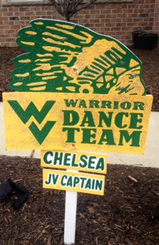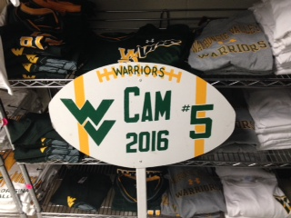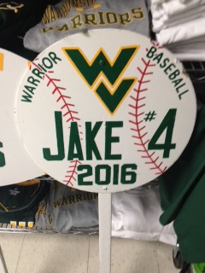

Yard Signs - Completely Customized with Player Names & Numbers
Order Form
Contact Information:

Name
Phone ( ) -Email ___________________________
Address _____________________________________________________________
Sign Information:
Organization: Waubonsie Valley Sport/Activity:
Name on Sign: ______________________
Jersey # (if desired) Grad Year:
Notes: ______________________________________________________________
____________________________________________________________________________
you can add current year, position player, etc to the sign for no additional cost, just note it here. Signs are all hand-painted and weather-proof, signs are ~ 22" x 14" with 40" stake or ~ 16" in diameter.

To order:
Print and complete this order form and label it:

Waubonsie Valley High School Warrior Warehouse
(MAKE CHECK PAYABLE TO "WVHS Boosters")

send it with your highschooler with payment to the school store - Warrior Warehouse just outside the cafeteria. There is a mailbox outside the store.

Turnaround time to complete signs varies depending upon current order backlog. Typically, signs are completed within 14 days from receipt of order form and payment. You will be contacted upon completion to arrange delivery of your sign. Questions contact melsantoro@aol.com or rothfamily5@wowway.com

